1、1000B-T测试命令

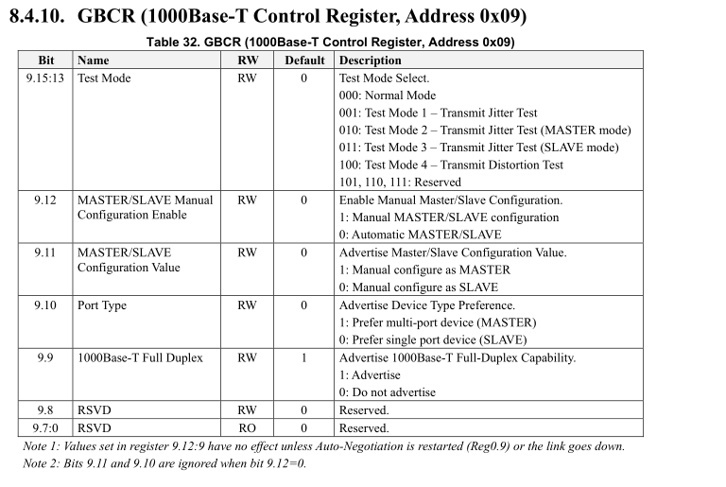

su

cd /sys/bus/mdio_bus/devices/stmmac-0:01

cat phy_registers /*获取寄存器值*/

echo 31 0x0005 >phy_registers /*初始化*/

echo 5 0x8b86 >phy_registers

echo 6 0xe200 >phy_registers

echo 31 0x0007 >phy_registers

echo 30 0x0020 >phy_registers

echo 21 0x0108 >phy_registers

echo 31 0x0000 >phy_registers

echo 0x09 0x7200 >phy_registers(具体指看示波器) /*写寄存器值，以 (mode3, Enable Manual, Manual configuration slave mode)为例，其余寄存器值按照示波器测试提醒在上表中查找相应的值即可*/

2、100B-T测试命令

su

cd /sys/bus/mdio_bus/devices/stmmac-0:01

echo 31 0x0004 > phy_registers

echo 16 0x4077 > phy_registers

echo 21 0xc5a0 > phy_registers

echo 31 0x0 > phy_registers

echo 0 0x8000 > phy_registers

=============================================

echo 24 0x0310 > phy_registers

echo 28 0x40c2 > phy_registers

echo 0 0x2100 > phy_registers

cat phy_registers